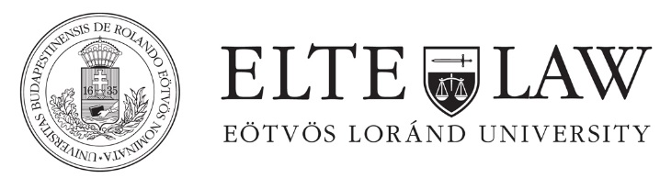

Semester schedule
Spring term 2017/18

Master in European and International Taxation

Week 1 (Friday)
09th February

Room: Main Building, Faculty Council Hall in Egyetem tér, basement : A/5

9.00-14.30. Bodies and Legal Sources of the EU* for Economists (6 x 45 minutes with 15 minutes break, room: I. floor 114. Room)
Lecturer: dr. Tamas Szabados

09.00-14.30: Fiscal Federeralism within the EU* for lawyers (4 x 45 minutes with 15 minutes break, room: A/5)
Lecturer: dr. Maria Lakatos, dr. Imre Tarafas, dr. Zoltan Bodnar

Week 1 (Saturday)
10th February

Room: A/5

09.00-16.15. VAT 1 (Introduction, history, directives, landmark cases) (8 x 45 minutes with 15 minutes break and one 45 minutes lunchbreak)
Lecturer: dr. Zsolt Szatmari

Week 2 (Friday)
23th February

Room: A/5

9.00-14.30. VAT 2 (Modern VAT case law in CEE) (6 x 45 minutes with 15 minutes break and one 45 minutes lunchbreak)
Lecturer: dr. Peter Darak

Week 2 (Saturday)
24th February

Room: A/5

09.00-16.15. Introduction to Customs, Excise Duties and Energy Taxation (8 x 45 minutes with 15 minutes break and one 30 minutes lunchbreak)
Lecturer: dr. Balazs Szuk

Week 3 (Friday)
09th March

Room: A/5

09.00-12.15: CJEU direct tax case law (4 x 45 minutes with 15 minutes break )
Lecturer: dr. Reka Somssich

13.00-14.30: OECD Mli (2 x 45 minutes)
Lecturer: dr. Robert Csabai

Week 3 (Saturday)
10th March

Room: A/5

09.00-14.30: CJEU direct tax case law (6 x 45 minutes with 15 minutes break and one 30 minutes lunchbreak)
Lecturer: dr. Reka Somssich

Week 4 (Friday)
23th March
Room: A/5

09.00-15.00: Direct tax directives (6 x 45 minutes and 1x 30 minutes with 15 minutes break and one 45 minutes lunchbreak)
Lecturer: dr. Frans Vanistendael

15.15-16.00: Fiscal State Aid Law
Lecturer: dr. Monika Papp

Week 4 (Saturday)
24th March

Room: A/5

08.30-10.15: Direct tax directives (2x45 minutes and 1x 15 minutes)
Lecturer: dr. Frans Vanistendael

14.00-16.30: Fiscal State Aid Law (5 x 45 minutes with 15 minutes break and one 45 minutes lunchbreak)
Lecturer: dr. Monika Papp

Week 4 (Saturday)
06th April

Room: A/5

09.00-12.15: Tax Planning in Practice within the EU (4 x 45 minutes with 15 minutes break)
Lecturer: dr. Arányi Attila and Gábor Beer

