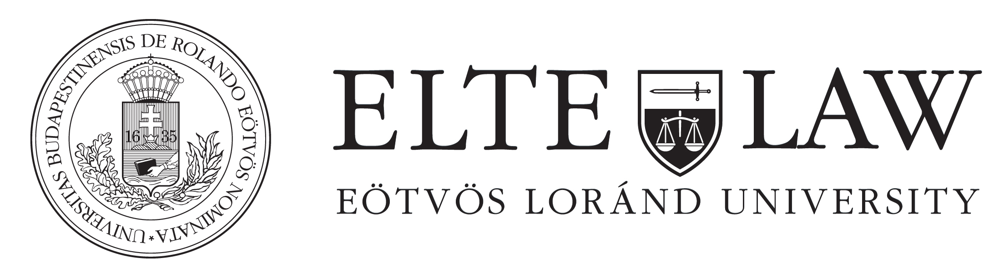

CROSS-BORDER CONTRACTS AND CROSS-BORDER DISPUTE RESOLUTION

Lecturer: Professor Dr. Dr. h.c. mult. Helmut Rüßmann
Universität des Saarlandes

The block seminar deals with legal and practical issues posed in cross border contracts of sale and in the resolution of cross border disputes and addresses the following questions:

• Which law applies?
• Which court decides?
• How can cross border services of documents be effected?
• Which language is to be used in the court?
o In briefs?
o In the taking of evidence (documents)?
• How can one get access to means of evidence in a foreign country?
• How can parallel proceedings and torpedo actions be avoided?
• Will a judgement in one country be recognised and enforced in the other country?
• Is there an alternative to state court dispute resolution?

Assessment

Written exam.

