INTERNATIONAL TRADE IN GOODS, SERVICES, CAPITAL MOVEMENTS (WTO, GATT, GATS, TRIPS, SMC, FTAs, complex agreements, Investment protection agreements)

Lecturer: Dr. Tamás Kende, associate professor / Department of International Law

e-mail: tkende@ajk.elte.hu

Course coveyed by Tamás Kende, Guest lecturers include János Katona and György Molnár-Bíró

Course description

The course is about the WTO and other trade agreements and ISDS. The course deals in depth with WTO institutions, decision-making, sources of law and the various multilateral and plurilateral agreements. The course also deals with trade in goods, trade in services, trade related IP and trade facilitation. On ISDS the course will deal with both the substantive provisions of BITs and the procedural questions of investor-state arbitration.

Course schedule

DATE | MATTER | READ
1. | Gatt-WTO history,  WTO sources of law,  WTO accession  WTO objectives and functions | 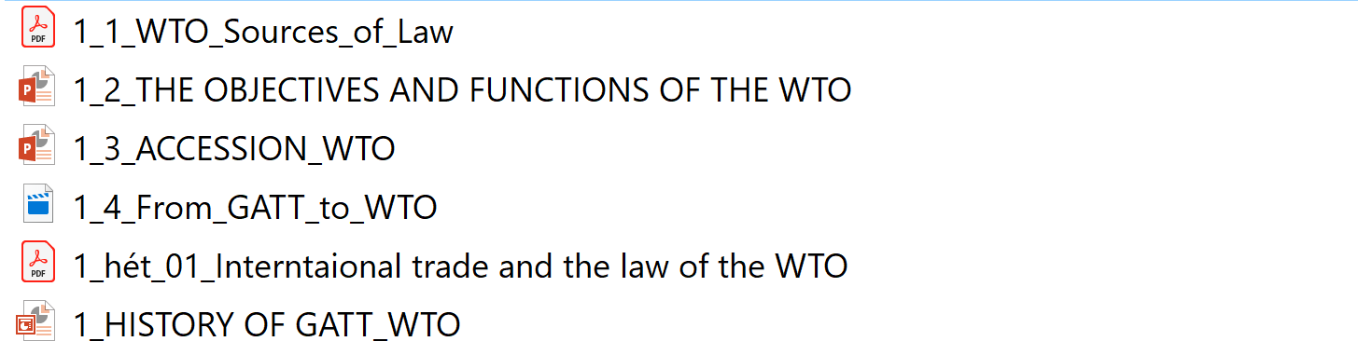
2. | WTO principles  exceptions to the principles  WTO organisation,  TPRM
3. | WTO dispute resolution | 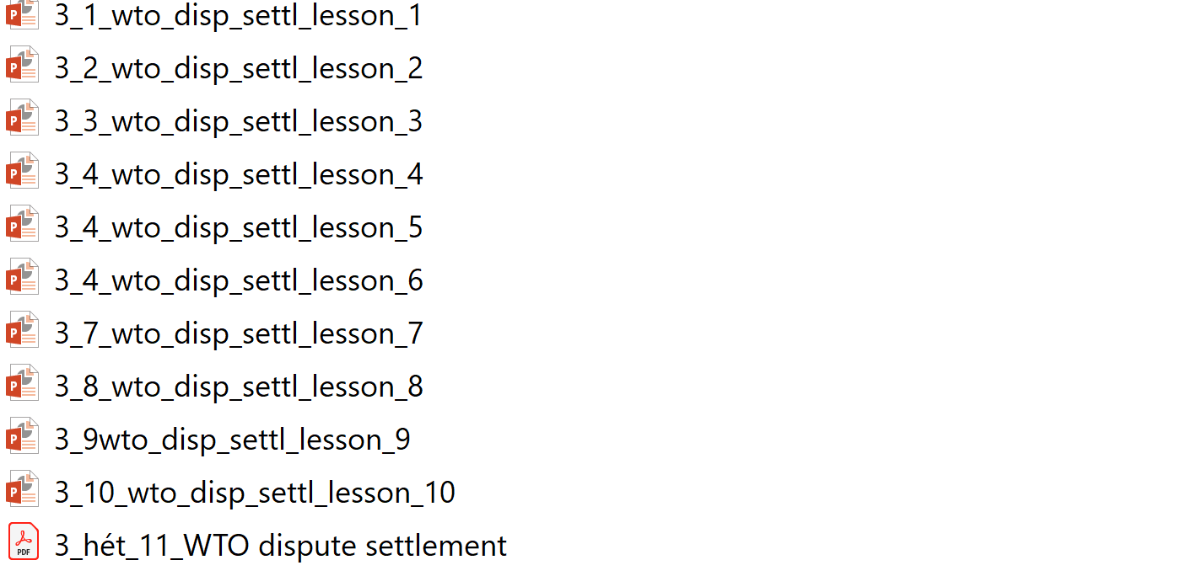  https://www.cfr.org/article/wto-dispute-settlement-system-fair  https://www.politico.eu/article/wto-donald-trump-protectionism-brussels-fears-trump-wants-the-wto-to-fail/  https://www.politico.eu/article/donald-trump-trade-disdain-for-system-casts-unease-over-wto/  https://www.politico.eu/article/russia-sanctions-europe-trade-eu-takes-billion-euro-battle/  https://www.politico.eu/article/eu-calls-donald-trump-bluff-over-wto/  https://www.politico.eu/pro/us-pushes-wto-to-brink-by-blocking-appointment-of-judge/  https://www.politico.eu/pro/donald-trump-jean-claude-juncker-trade-the-art-of-the-no-deal/  https://ec.europa.eu/commission/presscorner/detail/en/IP_20_113  http://www.europarl.europa.eu/doceo/document/TA-9-2019-0083_EN.html  https://www.ft.com/content/f0f992b8-19c4-11ea-97df-cc63de1d73f4  https://atlantic-community.org/healing-the-wto-cure-or-amputate-the-appellate-body/
4. | Trade in goods  TBT | 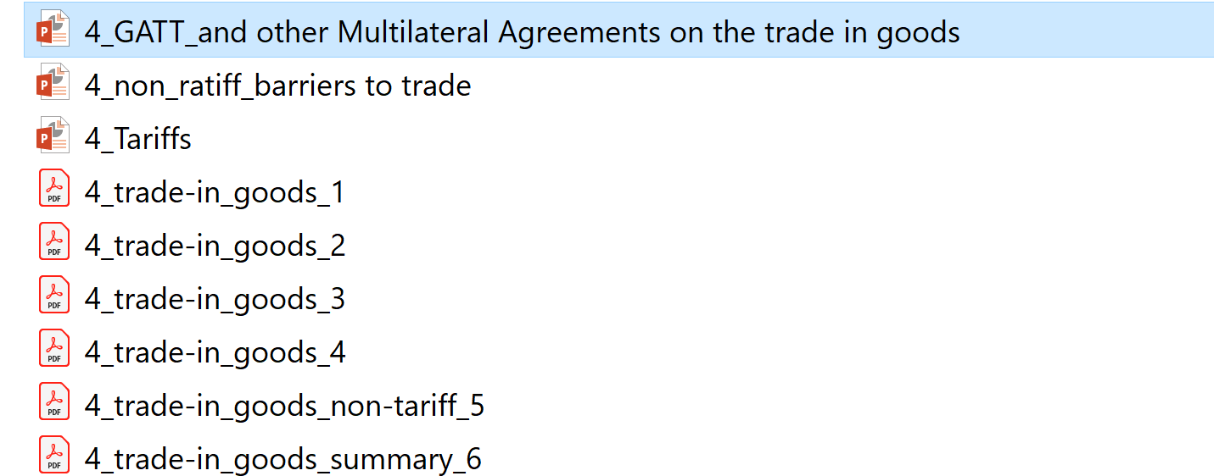
5.. | TFA  Trade in services  TRIPS | 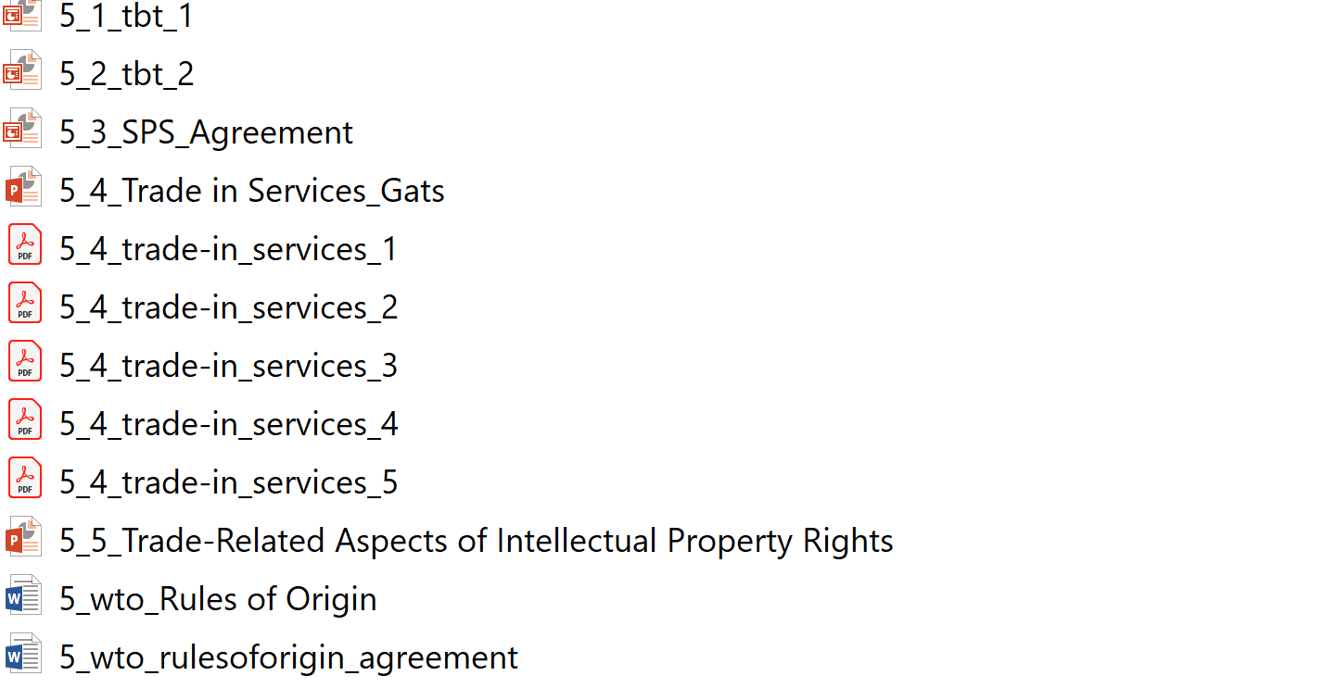
6. | - Investment protection 1.  - Introduction, history,  formation of investment protection law. | 7_Part1  MATTHIAS HERDEGEN: Principles of International Economic Law, Second Edition. OUP 2016 : Part I. CONTENTS, HISTORY, AND STRUCTURE OF INTERNATIONAL ECONOMIC LAW Chapter I.  Pauwelyn J, ‘Rational Design or Accidental Evolution? The Emergence of International Investment Law’ in Zachary Douglas, Joost Pauwelyn and Jorge E Viñuales (eds), The foundations of international investment law: Bringing theory into practice/(First edition).
7. | Investment protection 2.  Bilateral and Multilateral Investment Treaties | 8_Part2  Chapter 1 - p.11-30 Dolzer R and Schreuer C, Principles of international investment law (Second edition, Oxford University Press 2012)  or  HERDEGEN, Part V. Chapter XXXIV (Treaties on Investment Protection)
8. | Investment protection 3.  Dispute resolution in investment law  Investment law and other subsystems of the international legal order. | 9_Part3 and 9_Part4  Chapter 10 p. 211- 290 Dolzer R and Schreuer C, Principles of international investment law (Second edition, Oxford University Press 2012).  HERDEGEN, Part V. Chapter XXXVII.  Reinisch A, ‘The EU on the investment path- Quo vadis Europe?: The Future of EU BITs and Other Investment Agreements’ (2013). and  Tietje C and Wackernagel C, ‘Enforcement of Intra-EU ICSID Awards: Multilevel Governance, Investment Tribunals and the Lost Opportunity of the Micula Arbitration’ (2015) 16 The journal of world investment & trade 205.  Judgement of the ECJ Achmea (284-16) http://curia.europa.eu/juris/document/document.jsf?docid=201793&text=&dir=&doclang=EN&part=1&occ=first&mode=req&pageIndex=1&cid=12995341
9. |  | Term paper

Reading

- The Law and Policy of the World Trade Organization Text, Cases and Materials 3rd Edition Peter Van den Bossche Werner Zdouc, Cambridge University Press 2013
- Principles of International Investment Law Second Edition Rudolf Dolzer and Christoph Schreuer OUP 456 o.
- The Oxford Handbook of International Trade Law Daniel Bethlehem, Donald McRae, Rodney Neufeld, and Isabelle Van Damme Oxford Handbooks in Law 856 o. 2009
- M. Herdegen: Principles of International Economic law 2ed. OUP 2016.
- Joost Pauwelyn: Rational Design or Accidental Evolution? The Emergence of International Investment Law
- Christian Tietje & Clemens Wackernagel: Enforcement of Intra-EU ICSID Awards Multilevel Governance, Investment Tribunals and the Lost Opportunity of the Micula Arbitration
- August Reinisch: The EU on the Investment Path – Quo Vadis Europe? The Future of EU BITs and other Investment Agreements

- For Hungarians it may help to read the relevant chapters of Kende, Jeney & Szűcs Európai Közjog és politika Kluwer 2018

Assessment

Term paper: Open book exam in May from the readings and seminars.
Mid-term exam in March
Grading: Mid-term paper result 40%, Term-paper 60%.

