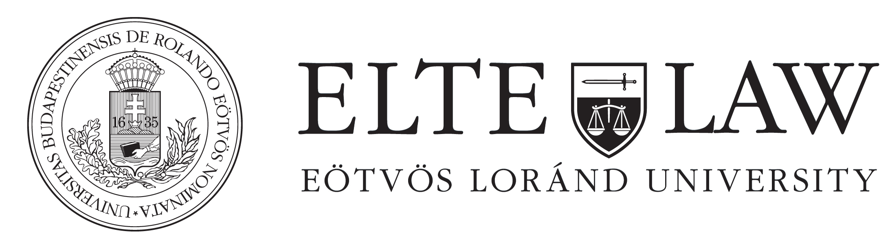

POLITICAL CULTURE IN THE EUROPEAN UNION

Lecturer: András Varga, MA

Institute of Political Science (ELTE)
Course description

The course seeks to give a comprehensive picture about the different political cultures among the member-states and tries to analyse the possible development of a European one.
Schedule

1st week | Introduction; requirements, program of the semester
2nd week | Basic concepts; concept of the political culture; typologies of the political culture; role of the political culture in the political system
3rd week | Consensus-oriented political culture
4th week | Conflictual political culture
5th week | Political decision-making in the EU
6th week | Political culture of the EU – neofunctionalism, technocratic leadership, compromise of Luxemburg
7th week | Political culture of the member-states# 1 – consensual old member-states
8th week | Political culture of the member-states#2 – conflictual old member-states
9th week | Political culture of the member-states#3 – Eurosceptic member-states
10th week | Political culture of the member-states#4 – post-socialist member-states
11th week | Political culture of the member-states#5 – southern member-states
12th week | Consultation
13th week | Evaluation of the essays

Curriculum

The curriculum composes all of the reading materials and the information presented during the classes.
Reading materials

- Simon Hix (Author), Dr Bjørn Høyland (Author) – The Political System of the European Union (The European Union Series) 1 Mar 2011
- Gabriel Abraham Almond és Sidney Verba – The Civic Culture: Political Attitudes and Democracy in Five Nations
- Roger Eatwell – European Political Cultures
Assessment
Essay

