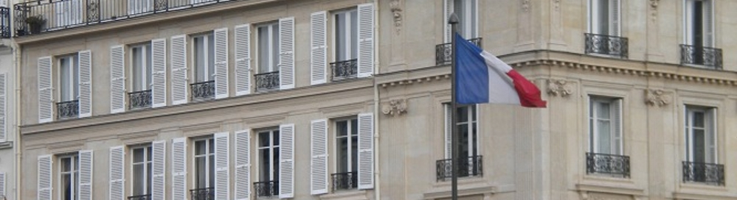
European election 2019 in France

The aim of the course

The aim of this course is to help students to familiarize themselves with the most important actors and institutions of the French political system and to urge them to follow day-to-day French politics through the analytical lens of the political scientist and of the political analyst.

In three months, students will learn a practical and step-by-step method to analyze and understand current events, that is the European Parliamentary campaign of 2019. They will be able to put these events in a wider French and European context. At the end of the semester, students should know their way around French and European politics, not only by understanding current affairs, but also by being able to historically and culturally contextualize these current affairs.

Attention! Knowledge of the French and Hungarian languages is not necessary for students in order to successfully accomplish the course, but fluent English is a must.

Date

Wednesday 4 P.M.

Structure

The present course will provide students with 1) background information on French politics 2) knowledge on current affairs, the European Parliamentary campaign of 2019. The seminar also aims to 3) expand the debating skills of students by addressing conflicting social and political issues through debate simulations.

Between two classes, the lecturer will also share relevant information and news with students through a public twitter account: @sooseszter. Students are required to read these materials and articles every week. According to recent observations, students are also active in sharing interesting news and analysis with each other.

Evaluation

Student performance will be assessed comprehensively. The final note will consist of three parts, according to the structure of the course itself:

- Presence and participation in debates regarding current affairs (50% of the final note),
- Presence and participation in readings discussions (50% of the final note),
- Erasmus students will be required to submit an extra piece of work (to be discussed with the lecturer on a case by case basis).

Attention! Please note that no more than two absences are allowed during the semester. Your written materials will be thoroughly verified by the use of online plagiarism checkers. Plagiarism automatically results in failure of the seminar regardless of your prior work and test results!

Workload of the class

24x45 minutes of contact hours (2 hours / week, 12 weeks) + a minimum of 4x45 minutes of work at home hours (preparation for class and essay writing).

Eszter-Petronella SOÓS
lecturer

