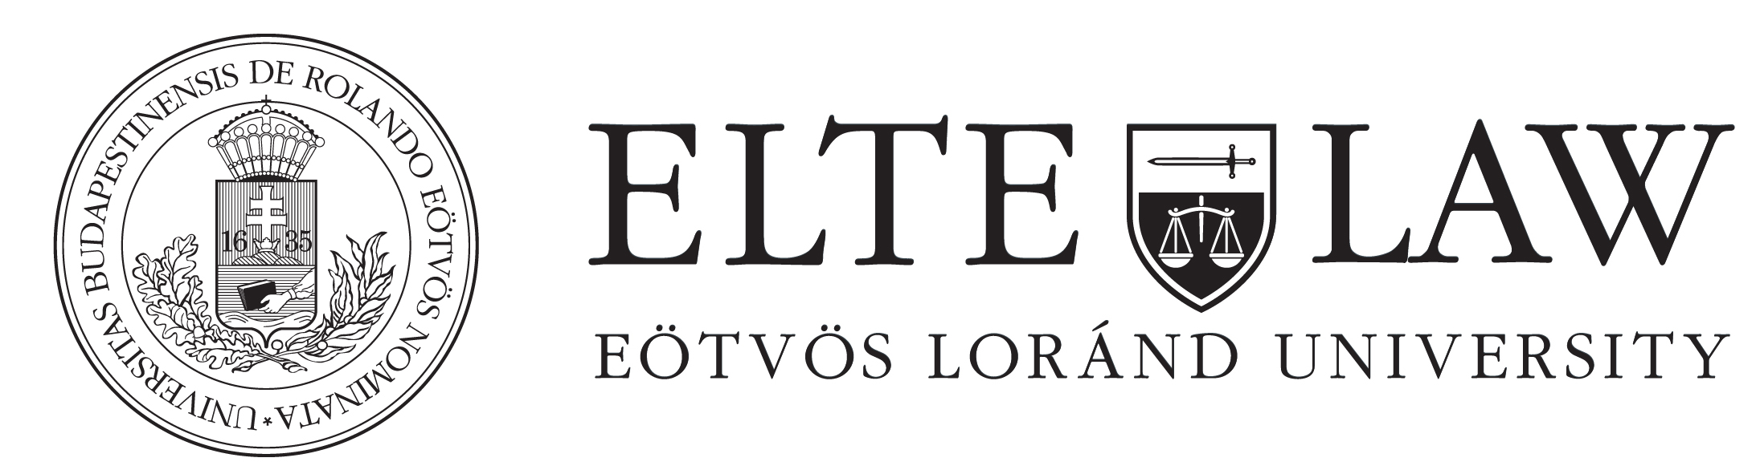

Democracy in Europe – old threats and emerging challenges in the functioning of the European Union under the aspects of democracy
Lecturer: András Varga, MA

Course description
The class will address the issue of the democratic deficit of the European Union. It includes the phenomenon’s theoretical overview in the literature, the analysis of its presence on the field and its changing characters as well.
The lecture is trying to give an overall picture about the democratic shortcomings of the integration, making a detailed analysis with the participation of the students. The subject of the course will be viewed from the aspects of different disciplines as political sciences, international relations, economy and law.
During the seminar the students will have to make presentations about the assigned readings, elaborate analysis and participate in the discussions.
At the end of the semester students can choose between the oral exam and the writing of a research paper as well.

Class schedule
- Introduction. Basic concepts. Authority, legitimacy, democracy, democratic deficit.
- Different forms of legitimacy. Input, throughput and output.
- Analysis of the legitimacy of the European Union
- The concept of the democratic deficit. The Moravcsik, Majone - Hix, Follesdal debate.
- The concept of governance. Actors and methods. Relation with democracy.
- The economic governance of the European Union.
- The economic crises in the US and in Europe.
- The European economic crisis management.
- Analysis of the different steps of the crisis management from the aspects of political sciences, international relations, economy and law.
- Overall examination of the crisis management.
- Oral exam and evaluation of the research papers.
Bibliography
- Majone Giandomenico – Europe’s ‘Democratic Deficit’: The Question of Standards in European Law Journal, Vol. 4, No. 1, March 1998, pp. 5–28; Blackwell Publishers Ltd. 1998, 108 Cowley Road, Oxford OX4 1JF, UK and 350 Main Street, Malden, MA 02148, USA
- Moravcsik Andrew – In Defence of the ‘Democratic Deficit’: Reassessing Legitimacy in the European Union in Journal of Common Market Studies, 2002 Volume 40. Number 4. pp. 603– 24 ; Blackwell Publishers Ltd 2002, 108 Cowley Road, Oxford OX4 1JF, UK and 350 Main Street, Malden, MA 02148, USA
- Follesdal Andrea, Hix Simon – Why There is a Democratic Deficit in the EU: A Response to Majone and Moravcsik in Journal of Common Market Studies, 2006 Volume 44. Number 3. pp. 533–62 ; Blackwell Publishing Ltd, 9600 Garsington Road, Oxford OX4 2DQ, UK and 350 Main Street, Malden, MA 02148, USA
- Bekkers Victor, Edwards Arthur, Legitimacy and Democracy: A Conceptual Framework for Assessing Governance Practices in Bekkers et al. – Governance and the Democratic Deficit, 2007, p. 35-61
- Bekkers Victor, Dijkstra Geske, Edwards Arthur, Fenger Menno – Governance and the Democratic Deficit: An Evolution in et al, 2007 in Bekkers et al. – Governance and the Democratic Deficit, 2007, p.269-312, 2007
- Bellamy Richard – Democracy without democracy? Can the EU's democratic ‘outputs’ be separated from the democratic ‘inputs’ provided by competitive parties and majority rule? in Ed. Mair Peter – Political Representation and the European Union Governance; Routledge, Taylor & Francis Group; 2 Park Square, Milton Park, Abdingon, Oxon, OX144RN , 2011
- Bieber Roland – Observer, policeman, pilot; On lacunae of legitimacy and the contradictions of financial crisis management in the European Union; Inaugural Lecture, European University Institute, Law Department, Florence, 30 settembre 2011
- Van Nipsen, Frans; Posseth, Johan: Democratic Legitimacy of Economic Governance: The Case of the Economic and Monetary Union in Bekkers, Victor et al.: Governance and the Democratic Deficit, 2007, p.223-246
- THE ECONOMIST – The ECB's new bond purchase programme, Not too little, possibly too late in The Economist, economist.com, 2012. szeptember 6.
- THE ECONOMIST – Euro yone crisis, Sad Cyprus in The Economist, economist.com,12/03/2013
- THE ECONOMIST – The euro crisis, Waiting for the fall-out in The Economist, economist.com, 25/03/2013
- THE ECONOMIST – What happened in Cyprus, An interview with Athanasios Orphanidas in The Economist, economist.com, 28/03/2013
- THE ECONOMIST – The Economist explains What is a bail-in? in The Economist, economist.com, 2013. április 7.
- Krugman, Paul – Can Europe be saved? in New York Time, 12/01/2011
Suggested readings
- Desai Padma – From Financial Crisis to Global Recovery Columbia University Press, New York 2011
- Lorca-Susino Maria – The Euro in the 21th Century, Ashgate Publishing Company, Burlington, 2010
- Zandstra Patty – The OMC and the Quest for Democratic Legitmization: The Case of the European Employment Strategy in Bekkers et al. – Governance and the Democratic Deficit, 2007, p.249-268
- Kjaer Poul F – Beetween Governing and Governance; On the Emergence, Function and Form of Europe's Post National Constellation; Hart Publishing, Oxford and Portland, Oregon, 2010
Didactic method

lecture, seminar, discussions
Examination

oral exam or research paper

