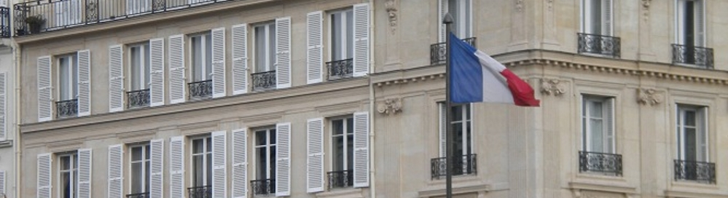
French politics
- syllabus -

Spring semester of the 2015/16 academic year

The aim of the course

The aim of this course is to help students to familiarize themselves with the most important actors and institutions of the French political system and to urge them to follow day-to-day French politics through the analytical lens of the political scientist and of the political analyst.

In three months, students will learn a practical and step-by-step method to analyze and understand current events. They will be able to put these events in a wider French context. At the end of the semester, students should know their way around French politics, not only by understanding current affairs, but also by being able to historically and culturally contextualize these current affairs.

Attention! Knowledge of the French and Hungarian languages is not necessary for students in order to successfully accomplish the course, but fluent English is a must.

Date

Wednesday 4 P.M.

Structure

The present course will provide students with 1) background information on French politics 2) knowledge on current affairs. The seminar also aims to 3) expand the debating skills of students by addressing conflicting social and political issues through debate simulations.

Between two classes, the lecturer will also share relevant information and news with students through a public twitter account: @sooseszter. Students are required to read these materials and articles every week. According to recent observations, students are also active in sharing interesting news and analysis with each other.

Evaluation

Student performance will be assessed comprehensively. The final note will consist of three parts, according to the structure of the course itself:

- Presence and participation in debates regarding current affairs (25% of the final note),
- Presence and participation in readings discussions (75% of the final note),
- Erasmus students will be required to submit an extra piece of work (to be discussed with the lecturer on a case by case basis).

Attention! Please note that no more than two absences are allowed during the semester. Your written materials will be thoroughly verified by the use of online plagiarism checkers. Plagiarism automatically results in failure of the seminar regardless of your prior work and test results!

Indicative program

 | Topic to discuss
1. | Introduction. Actors and institutions in the French political system.  Reading: the Constitution of the French Republic
2. | The 1958 constitution and its birth. Main modifications of the Constitution. Separation of power in the French system  Reading 1.: the Constitution of the French Republic  Reading 2.: Poulard, Jean, “The French Double Executive and the Experience of Cohabitation”, Political Science Quarterly, Vol. 105, No. 2 (Summer, 1990), pp. 243-267.
3. | Presidents and governments. A brief introduction to the political history of the Fifth Republic  Reading: Price, Roger: A concise history of France / Franciaország története (excerpts)
4. | The Socialist Party  Reading: Wagner, Markus: “Debating Europe in the French Socialist Party: The 2004 Internal Referendum on the EU Constitution”, French Politics (2008) 6, 257–279.
5. | The gaullist movement (UMP, Republicans)  Reading: Gaffney, John: “Leadership and style in the French Fifth Republic: Nicolas Sarkozy’s presidency in historical and cultural perspective”, French Politics (2012) 10, 345–363.
6. | Centrists, greens, communists and their political organizations (MoDem, EELV, Front de Gauche, PCF etc.)  Reading: Pappalardo, Adriano, “The French two-round system and party format: From extreme pluralism to concentration?”, French Politics (2010) 8, 377–401.
7. | The National Front (FN)  Fredette, Jennifer (2014), Constructing Muslims in France: Discourse, Public Identity, and the Politics of Citizenship, Temple University Press, Philadelphia. (Chapter 1.)
8. | Nation and citizenship  Reading: Safran, William: “State, Nation, National Identity, and Citizenship: France as a Test Case”, International Political Science Review, 1991 12: 219,
9. | The 2007 and 2012 presidential campaigns and their consequences.  Reading: Kuhn, Raymond: “‘Mirror, mirror ...’: Performance and presidential politics in contemporary France”, French Cultural Studies, 24(3) 293-305.
10. | The 2017 presidential campaign.
11. | The Macron phenomenon. En marche !
12. | Discussion, evaluation, catching-up.
13. | Discussion, evaluation.

Workload of the class

24x45 minutes of contact hours (2 hours / week, 12 weeks) + a minimum of 4x45 minutes of work at home hours (preparation for class and essay writing).

Eszter-Petronella SOÓS
lecturer

