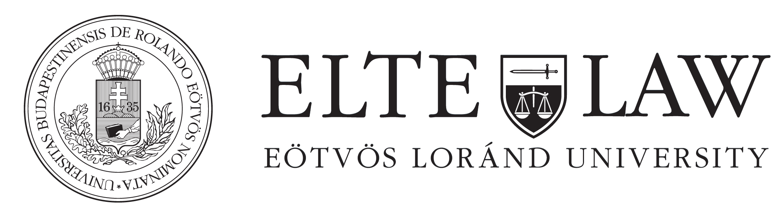

Introduction to the International Capital Markets
Lecturer: Blaise Pasztory / Attorney (New York), Honorary Professor, ELTE
E-mail: bpasztory@aol.com
Office address:
Blaise Pasztory, Counsel
KCG Partners Law Office
Szecheny rakpart 8.,
Commerzbank Building, 3rd Floor
1054 Budapest, Hungary
Brief Introduction
This seminar is intended to introduce students to the legal framework of the Capital Markets and Securities Regulation throughout the world but will focus particularly on the European Union and on the United States. It will deal with the past by analyzing in detail the lessons learned from the Financial Crisis of 2007/2008 but it will also deal with the future by covering the changes in laws and regulations that are likely to occur as a result of BREXIT (the decision of Great Britain to leave the European Union) of the change in control of the three branches of Government (executive, legislative and judicial) from the Democrats to the Republicans.
A purpose of the seminar is to familiarize the participants with all the significant investment strategies and procedures, including the most recent ones, such as "hedge funds","exchange traded funds", "derivatives", "securitization", "credit default swaps", BITCOIN, etc.
Course schedule/outline
An outline of the topics covered by each of the lectures will be distributed to the students shortly before the commencement of the seminar.
Literature/Textbook/Materials
- Textbook: Blaise Pasztory, Introduction to the International Capital Markets, ELTE Law Course Books (ELTE Jogi Kari Jegyzetek), Eötvös University Press, Eötvös Lóránd University (2017).
- Supplementary materials, including statutes, regulations, commentaries and articles will be distributed to the students from time to time throughout the semester.
Assessment/Exam
There will be an open book examination given to the students in the seminar at the end of the semester.

