INVITATION

Workshop
Jean Monnet Module
‘Perspectives of Unification of Private International Law
in the European Union’

15 June 2018
Faculty of Law, ELTE Eötvös Loránd University, Budapest
Faculty Council Hall
(1053 Budapest, Egyetem tér 1-3. GF 1.)

PROGRAMME
m

12:00 Welcome speech by Prof. Miklós Király (ELTE)

12:10 Prof. Miklós Király (ELTE): The Interface Between the Harmonisation of Contract Law and Private International Law
Comments by Dr. Zoltán Nemessányi (Corvinus University)

12:40 Dr. Tamás Szabados (ELTE): Companies in EU Private International Law – An EU Law Perspective
Comments by Dr. Éva Gellérné Lukács (ELTE)

13:10 Discussion

13:30 Coffee break

13:45 Dr. Réka Somssich (ELTE): Uniform or Diverging Application of EU Instruments in the Field of Private International Law by National Jurisdictions – Preliminary References in the Area of Judicial Cooperation in Civil Matters
Comments by Dr. Orsolya Szeibert (ELTE)

14:15 Dr. István Erdős (ELTE): Illusion or Reality: the Interrelation of the Conflict of Laws Rules and the Practices of State Courts and Arbitral Tribunals
Comments by Dr. Aliz Káposznyák (ELTE)

14:45 Discussion

Attendance is free of charge, but we kindly ask you to register for the workshop by email (jmce@ajk.elte.hu).
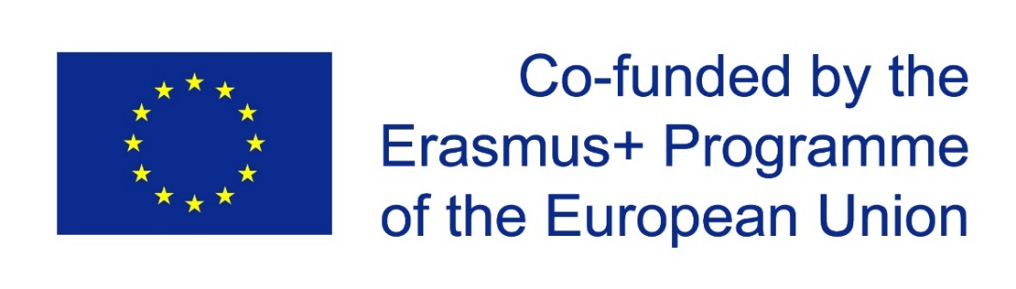
Jean Monnet Module ‘Perspectives of Unification of Private International Law in the European Union’ with the support of the ERASMUS+ programme of the European Union.

